Finding a Topic for Your ISEF project
The process of finding an idea for a project is the hardest part of the project for many people – and there isn’t one single way to do it that is right for everyone. In this packet, you’ll find a few different brainstorming methods to try. We encourage you to play with them a bit. The four methods here are:

- Self Question-and-Answer
- Mind-mapping
- Group brainstorming
- Project topic Wizard

Brainstorming methods are only as good as the effort you put into them, though, so it pays to do some planning even before you launch into your idea search. Collect your thoughts here and develop some useful constraints for your brainstorming session:
SET a time limit – We work better with deadlines, so, tell yourself you’ll brainstorm for a set time, whatever works for you – and commit to meeting your goal of choosing an explorable idea at the end of that time.
- How much time will you spend on thinking about your topic? _____________________________________
- How much time can you spend doing some background research to begin learning more about this? ________________
FREE yourself from worrying about whether your idea is perfect – it can evolve as you go!
It truly is useful to take a leap, and make a choice that seems best of what is available to you for your project idea. Getting started is key, and you can then discuss and modify your idea from that starting point – or even start over, with new and better knowledge!
MAKE creative connections – don’t be afraid to link up ideas from different fields.
If you wonder why birds like woodpeckers don’t get concussions like football players do, then by all means, combine sports medicine and ornithology and zoology! If you love art and are fascinated by psychology, see you if you can find out how to combine them to understand why people find some things beautiful. Almost ANY field of thought can provide inspiration to scientific thinking and experimental design.
When you start looking into your short-list of topics more closely, FOCUS your information search – write down guiding questions to get the best background to serve your needs. Use question words who/what/when/where/why/how, combined with keywords you find or develop, to ask why things happen, how they happen, what causes them to happen, what are the key steps or properties, and so on.
- What field or fields of science apply to this topic?
- How would you state the central question of your project – what would you like to discover or solve?
- What are some keywords involved in your question, and how are those defined?
- How many people/animals/beings are affected by this topic?
- Who is a leading researcher in this topic and what have they found?
- What are some of the latest breakthroughs in this topic?
- Why is this topic important or of interest? In other words, how does this topic pass the “so what” test?
KNOW your own strengths and what motivates you best – use your strengths in new ways to develop your project idea and set goals that keep you moving forward.
- What skills have you already developed that you could use in your project?
- Which would you enjoy more: discovering new knowledge (inquiry/experiment) or designing and building a solution to a problem (engineering)?

Brainstorming Method #1: Topic Selection - The Self Q & A Approach
If you’re trying to come up with a topic for the science symposium, you might be helped by working through the guiding questions here. Write answers out on a separate sheet of paper or in your project logbook. Try to answer as many as you can, but if a question just seems too difficult or unrelated to your experience, then you can skip it. The idea is to get your thoughts together and see where they lead:
- List 3 of your own greatest interests. These should be topics you think about when you’re free to focus purely on your interests.
- List 3 problems in the world that you believe are significant and in need of solutions.
  - What could you learn from studying the problem?
  - How could research lead to a solution or solutions?
- Think of your favorite hobby.
  - Is there something that’s annoying or doesn’t work very well?
  - Are there changes that could be made to make this activity more efficient or enjoyable?
- What line of work do you wish to pursue in the future?
  - What problems exist in this field? What would solutions to these problems include or involve?
  - How might this work be made easier?
- Read current events in a national newspaper or on a general science website (Discover, National Geographic, Scientific American, Science News all have websites with lots of breaking-news articles on a wide variety of topics).
  - Are there issues or ideas here that look interesting to you? Something that grabs you or makes you think it would be fun to research, timely and important? Be sure to keep track of places where you find good information – you might need to go back to it later.
- Can you read a book or articles that aren’t directly related to things you normally enjoy or are interested in? Just spend 20-30 minutes to find and read an article about something you know nothing about – choosing something from one of the news websites listed above can be an easy way to find these. What connections can you make to things you already do know about?
- What do your answers to the questions above have in common? What have you written that inspires the greatest feeling of curiosity for you – what makes you want to know more?
Once you have a topic in mind, explore its potential further with these questions:
- Rate how interesting this topic sounds to you on a scale of 1-10.
- Is there a way you can measure something (dependent variable) in this project that will let you test an idea or a new design?
- Is there something you can change to affect this thing you’d measure (independent variable)?
- Can you control other variables so they won’t impact your measurements?
- Will you be able to collect enough data – say, find more than 30 possible items/beings to test or measure, or have enough time to do repeat trials of an engineering design?
- How long do you think this project will take?
- Do you know of any specialized equipment or materials you’ll need?
- If you are studying humans, are you willing to recruit participants and get signed consent from them, and from parents or guardians if they are minors/dependents?
- If you want to study vertebrate animals, are you prepared to care for them and plan for what happens with them at the end of your experiment if necessary?
- What do you think, for now, might be your biggest hurdle in exploring this topic?

Brainstorming Method #2—Mind Mapping!
Mind mapping refers to a technique that designers and engineers use to express and generate ideas. All that mind mapping really is, however, is a way to get all of the ideas in your head down onto paper. There is no right or wrong way to mind map. It is simply a visual representation of the thoughts in your head, and it often looks like organized chaos.

Why Mind Map?
Mind mapping helps you to release all of the ideas in your head and gives you the opportunity to see those ideas visually. It is a fast and simple way to get your creative juices flowing, and the only tools you need are a pen or pencil and your design notebook.

How to Mind Map
To start a mind map, write down one, central idea or theme in the middle of a blank page. All mind maps have this common starting point. Then, stem off of the central idea by writing down anything that comes to your mind when thinking about the idea. You can include drawings, questions, comments, solutions, problems, etc. There are no limits. Simply write down everything that relates to the central theme or anything that enters your mind.

When and What to Mind Map
You can create a mind map at any stage in your design process and for absolutely any purpose. You can mind map at the very beginning before you have even decided what problem you are going to solve. You can also mind map to generate possible solutions to your problem or to identify different types of users for your project. Mind map whenever you feel the need to empty the thoughts in your head or whenever you feel stuck during the design process.

Examples here: https://www.sciencebuddies.org/science-fair-projects/engineering-design-process/mind-mapping

Brainstorming Method #3 – the Group Idea Generation Approach
Adapted from http://www.exploravision.org/how-brainstorm
Group brainstorming is a helpful and fun way to think of creative solutions to a problem. The theory is that by coming up with as many ideas as possible and not limiting your thinking, you'll discover new, unusual and creative ideas.
Brainstorming tends to work better with a group of three to six people, so this is a method of idea generation that you will use with your family or friends. You should be the leader, and someone should be the recorder. The recorder is in charge of writing all the ideas down where everyone can see them on a white board, chalkboard or big flip pad, or sheets of paper.
- Define the question. Before you start, everyone should agree on the problem you are trying to solve or question you want to answer. If you don’t already know what topic you want to tackle, you should do a group brainstorm session to create a list of interesting topics first, and vote on those before you start thinking about how to come up with the best experimental project question or engineering problem to solve. Start with a question that's not too broad — you can always have additional brainstorming sessions. As a group, you might pick a word or words to fill in the blanks of the following questions to start your brainstorming session.
  - "What is an imaginary new product that could help______?"
  - "How will ______ be improved in the year 3000?"
  - "If you could make the perfect ______, what would it do?"
  - "What if we combined _____ and ______?"
  - How could __________ be used to do _______________? (for example, how could bacteria be used to make fresh water from seawater?)
- Watch the clock. Give yourself a set time limit for coming up with ideas. 15 to 20 minutes is probably ideal. On your mark, get set, go!
- Write down every idea. Once the brainstorming starts, participants shout out ideas as they come to mind. Don't limit yourself — one of the keys to successful brainstorming is the acceptance of EVERY idea — even those that seem silly or impossible. No one is allowed to criticize or limit any of the ideas during the brainstorming session, because you never know where the next great inspiration is going to come from!
- After time is up, the group should talk about which ideas are favorites and why certain ones would work better than others. As a group, vote on which idea you like best! As the principal scientist, your decision is the most important, though, so you can choose something else from the list if you want, even if it doesn’t get the most votes.

Brainstorming Method #4 – the Wizard Approach (yep, we said Wizard…welcome to Hogwarts-style brainstorming!)

Jump on a computer, point your Internet browser to http://www.sciencebuddies.org and click on “Find A Project Idea” and then “Topic Selection Wizard”:
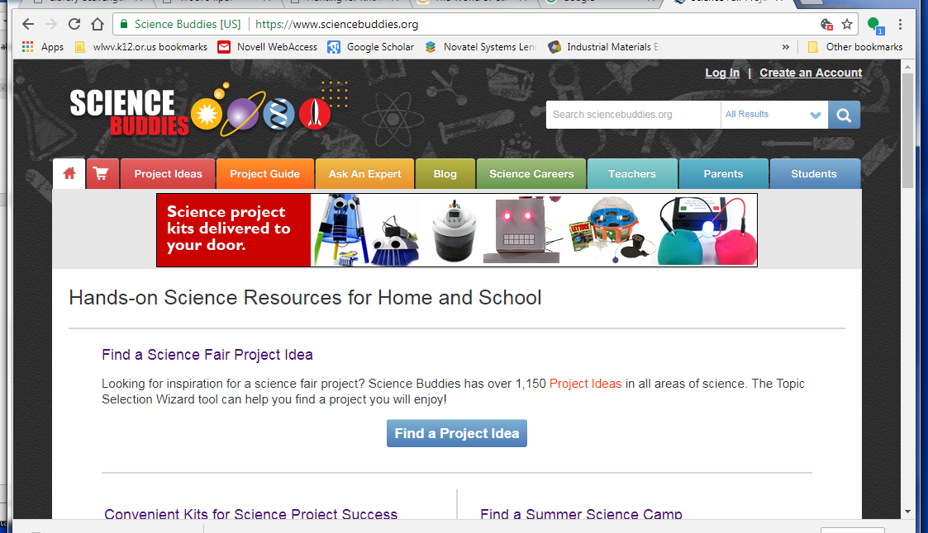
The answers to the first three questions that come up:
- you have until the beginning of February 2020 to get this done
- your grade level in the fall
- no, you are not being assigned to do a project in a particular subject area
NOTE that all kinds of project ideas will come up based on the answers you give to the other questions in this Wizard tool. Use this list of ideas to spark further thinking – don’t just do a project that has already been published online, because chances are someone else might do the very same thing! You want to be original. This Wizard is an excellent tool for focusing your interests, giving you a solid idea of what you need to include in your project planning (explore their projects and you’ll see lots of detail in many of them), and offering a great jumping-off point for your own original project!
List ideas you found here:

