WLHS/Marine Biology/Oppelt

**Why Great White Sharks Are Still a Mystery to Us**

**Thanks to *Jaws*, they're the ocean's most iconic and feared fish. But we know surprisingly little about them.**

Much of what we think we know about great white sharks simply isn’t true. They aren’t merciless hunters, they aren’t always loners, and they may be smarter than experts have thought.

By **Erik Vance** Photographs by **Brian Skerry**

This story appears in the July 2016 issue of *National Geographic* magazine.   
  
This summer, we’re looking at three shark species with notorious reputations: tiger sharks, great whites, and oceanic whitetips. We’ll meet scientists who are shedding new light on these enigmatic creatures that are vital to the seas—and not as scary as you might think.

Meeting a great white shark in the wild is nothing like you expect it would be. At first glance it’s not the malevolent beast we’ve come to expect from a thousand TV shows. It’s portly, bordering on fat, like an overstuffed sausage. Flabby jowls tremble down its body when it opens its mouth, which otherwise is a chubby, slightly parted smirk. From the side, one of the world’s greatest predators is little more than a slack-jawed buffoon.

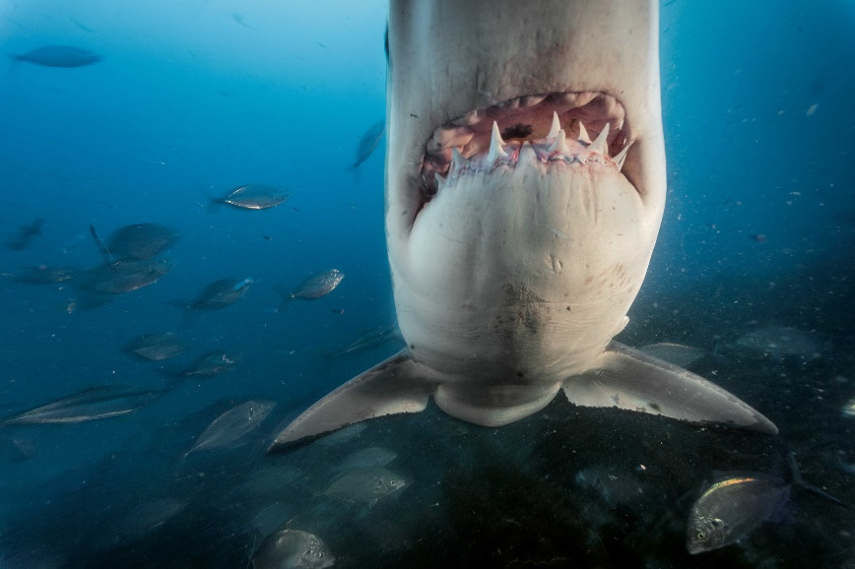It’s only when the underwater clown turns to face you that you understand why it’s the most feared animal on Earth. From the front its head is no longer soft and jowly but tapers to an arrow that draws its black eyes into a sinister-looking V. The bemused smile is gone, and all you see are rows of two-inch teeth capable of crunching down with almost two tons of force. Slowly, confidently, it approaches you. It turns its head, first to one side and then the other, evaluating you, deciding whether you’re worth its time. Then if you’re lucky, it turns away, becoming the buffoon again, and glides lazily into the gloom.

Perhaps no other animal stirs primal panic like a great white shark. This one returned again and again to investigate a caged diver in waters off Australia. But scientists say people may pose more of a threat to great whites than the sharks pose to people.

There are more than 500 species of sharks, but in popular imagination there’s really only one. When Pixar needed an underwater villain for its animated film *Finding Nemo,* it didn’t look to the affable nurse shark or the aggressive bull shark. Not even the tiger shark, which would be more appropriate in Nemo’s coral-reef home. It was the great white shark—with its wide, toothy grin—that was plastered on thousands of movie billboards across the world.

The [great white shark](http://animals.nationalgeographic.com/animals/fish/great-white-shark/) is the ocean’s iconic fish, yet we know little about it—and much of what we *think* we know simply isn’t true. White sharks aren’t merciless hunters (if anything, attacks are cautious), they aren’t always loners, and they may be smarter than experts have thought. Even the 1916 Jersey Shore attacks famously mentioned in *Jaws* may have been perpetrated by a bull shark, not a great white.

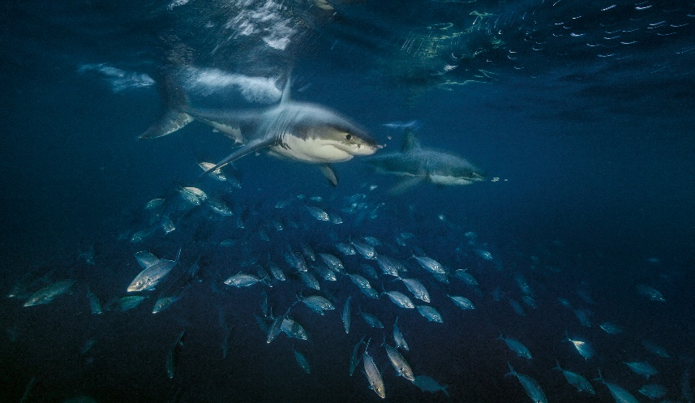We don’t know for sure how long they live, how many months they gestate, when they reach maturity. No one has seen great whites mate or give birth. We don’t really know how many there are or where, exactly, they spend most of their lives. Imagine that a land animal the size of a pickup truck hunted along the coasts of California, South Africa, and Australia. Scientists would know every detail of its mating habits, migrations, and behavior after observing it in zoos, research facilities, perhaps even circuses. But the rules are different underwater. Great whites appear and disappear at will, making it nearly impossible to follow them in deep water. They refuse to live behind glass—in captivity some have starved themselves or slammed their heads against walls. (Several aquariums have released them for their own safety or because they were attacking tank-mates.)

Searching for seals, two sharks swim near the Neptune Islands. Great whites do not live in groups, nor are they purely solitary creatures. Sometimes they congregate near food.

Yet scientists today, using state-of-the-art technologies, may be on the verge of answering two of the most vexing mysteries: How many are there, and where do they go? Unraveling these mysteries could be critical to deciding how to protect ourselves from them and them from us. When we finally see the great white clearly from all angles, will the world’s most fearsome killer deserve our fear or our pity?

**A 24-foot fishing boat**sits just off the southern tip of Cape Cod, Massachusetts, on a perfect summer afternoon. The passengers—three scientists, two paying customers, two journalists, and the boat’s captain—lounge on the seats, looking off toward Nantucket. The voice of a spotter pilot flying 1,000 feet above breaks out over the radio in a sharp New England accent. “We’ve got a wicked nice shark over here to the south!”

Fisheries biologist Greg Skomal perks up. He’s standing five feet off the bow on the pulpit, a fenced-in walkway resembling a pirate’s plank. If this were a Hollywood movie, he’d have a harpoon and a peg leg. Instead he carries a GoPro camera attached to a 10-foot pole. He grins like a little kid as the captain guns the engine.

**CAPE COD'S GREAT WHITES**

**1 / 4**

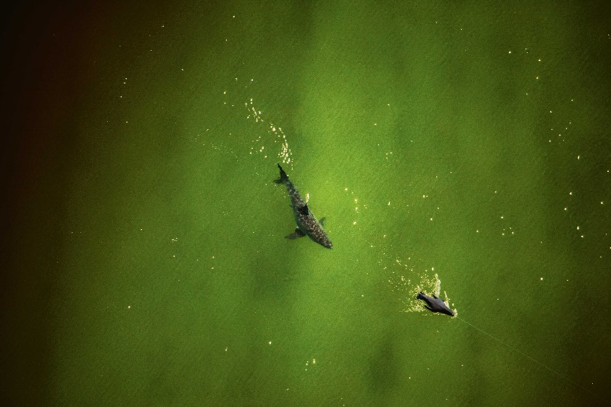A great white shark near Cape Cod (left) investigates a seal decoy. The waters off the cape, unlike other places inhabited by great whites, are shallow enough to spot sharks from the air.

A great white eyes a camera in a seal decoy near Cape Cod. This is a rare high-quality photograph of one in these waters. Great whites here are difficult to photograph because they aren’t attracted to chum.

A great white bites a seal decoy off Cape Cod. Sharks often attack cautiously, apparently fearing injury from a seal’s claw. Frequently they will bite, then back off and allow the prey to bleed to death.

Biologist Greg Skomal tries to record video of a great white near a popular swimming area off the cape. For the first time in modern history, great whites have begun regularly returning to the waters of this vacation spot.

Before 2004 hardly anyone in modern times saw great white sharks in the waters off the East Coast. Occasionally one would appear near a beach or in a fishing net, but they were anomalies. Elsewhere, great whites congregate seasonally around five “hubs” or territories, including California’s coast down to Mexico’s Baja California, South Africa’s southern shores, and Australia’s southern coast, where they gather to feed on seals. But there’s been no hub on the East Coast, nor have there been many seals. Sharks here were wanderers without a home. Then, in 2004, a single female found her way into shallow inlets and shoals near Woods Hole, Massachusetts.

For Skomal, who’d been tagging other sharks for 20 years, this was the chance of a lifetime—a great white in his own backyard. “I thought it was a fluke. This will never happen again,” he says with his broad, boyish grin under ruffled salt-and-pepper hair. Over the next two weeks Skomal and his colleagues followed the shark, which they named Gretel after the lost girl in the fairy tale, and affixed an electronic tracker on her. Tracking a white shark across the Atlantic Ocean offered a chance to solve so many riddles. But 45 minutes into the journey, Gretel’s tag malfunctioned and popped off. “I went from this superhigh to this really deep low, because I was convinced that this was the shot in my career to study a white shark,” Skomal says.

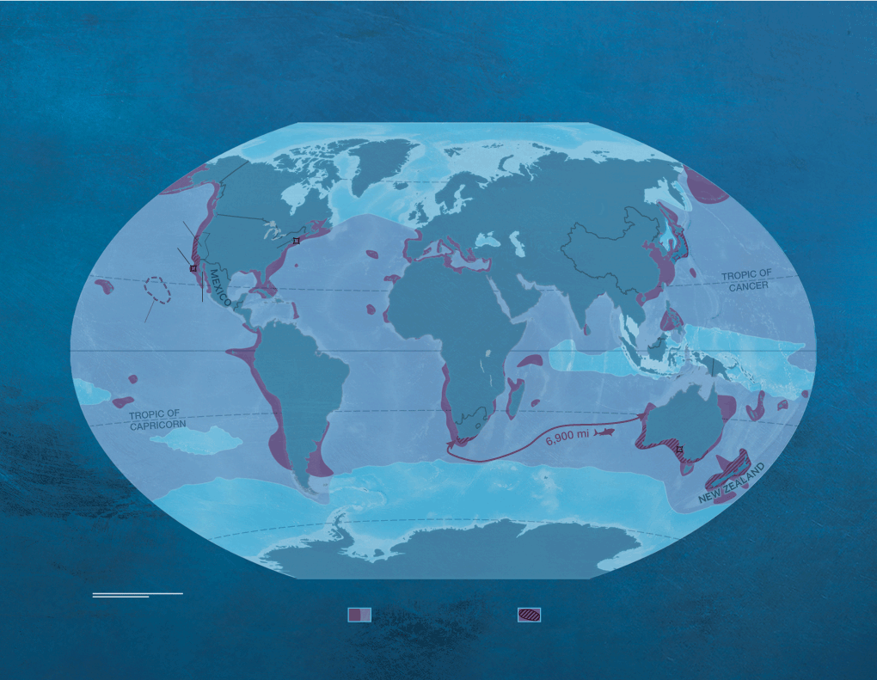

The Realm of the Great White

The great white is one of six shark species that are endothermic, which means they can raise internal body temperatures over that of surrounding waters. This allows great whites to inhabit extreme depths as well as cold waters of higher latitudes, while still being able to function efficiently to capture swift and agile prey.

It wasn’t. Over the next few years he thought a lot about Gretel and wondered whether she was indeed alone. Then, on Labor Day, 2009, everything changed. A pilot saw five great whites off the cape. Over that weekend Skomal tagged them all. “I absolutely freaked out. My adrenaline was pumping. My heart—I could feel it just pounding in my chest. This was everything I was dreaming of.”

White sharks have returned every summer since, leading some to call Cape Cod the sixth hub. How many great whites are there? For that we turn to the hub running from California to Baja California. The effort to count sharks there was pioneered by Scot Anderson while he was a volunteer seabird scientist in the mid-1980s on an island west of San Francisco’s Golden Gate Bridge. Anderson and others have tracked the sharks—at first by sight, then by acoustic tags, and most recently with satellites. During the past 30 years, teams have assembled thousands of observations of individual sharks recognized by the shape and marks of their dorsal fins, while others have used the distinctive line between their gray bodies and white underbellies. Scientists know where the sharks congregate and how they feed. And each year most sharks they see are the ones they saw in previous years.

This raised an intriguing question: With enough observations, could you use the sharks you see to estimate how many you can’t see? [In 2011 a team in California](http://rsbl.royalsocietypublishing.org/content/early/2011/03/03/rsbl.2011.0124) did just that and came up with just 219 adults in California’s most shark-rich region. Even among top predators, generally less abundant than their prey, that’s a tiny number. The study shocked the public and came under immediate attack from

Of course, counting great whites is a lot harder than counting land animals or even marine mammals. So scientists make massive assumptions about shark movements and then extrapolate. In California the biggest assumption was that a few feeding grounds were representative of the entire hub. Other teams crunched the same data using different assumptions, and one study estimated about 10 times more sharks. (That count was bolstered by adding juveniles, which the first excluded because so little is known about them.) Pretty soon scientists began quantifying white sharks in the other hubs. A team in South Africa estimated the population there at around 900, while another team put Mexico’s Guadalupe Island population, part of the California hub, at just 120 or so.

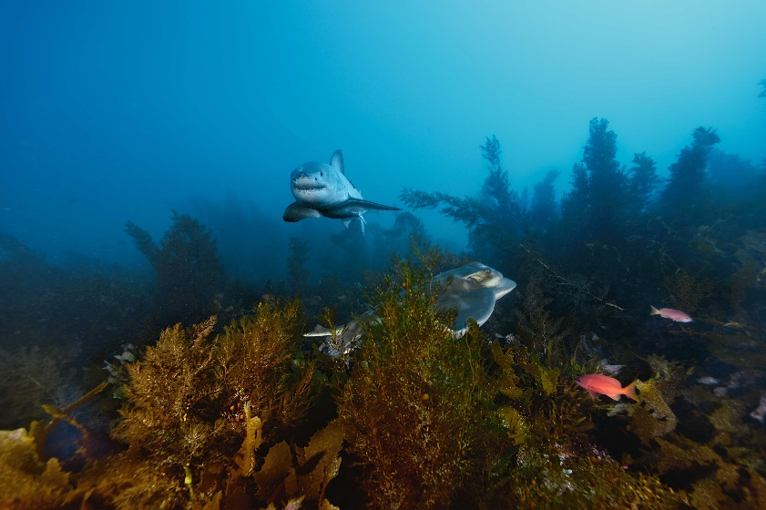Are these large numbers or small? Are great whites thriving or dwindling? The world has about 4,000 tigers and 25,000 African lions. Using the lowest estimates, global great white numbers resemble the estimate for tigers, an endangered species. Using the highest estimate, the population is closer to that of the lions, which are classified as vulnerable. Several experts see them heading toward extinction; others see a positive trend. Some say rising seal populations are a sign that great whites are nearly gone, while others say more seals mean more sharks. Aaron MacNeil, an Australian statistician who crunches shark data, says the appearance of sharks around Cape Cod and the increased activity in the Southern Hemisphere suggest the latter. “I haven’t seen any evidence in the last decade that white sharks are declining,” says MacNeil. “Yes, there is a historical depletion of white sharks. But the story is not that they are going extinct. The story is that they are probably increasing very, very slowly.”

The clear waters off Australia’s Neptune Islands are one of the best places in the world to see great white sharks. This one is cruising past a ray in a kelp forest.

There’s reason to be hopeful. Few if any fishermen target great whites today, yet a global pact, the Convention on International Trade in Endangered Species, gives white sharks its second strongest conservation rating because fishermen catch them unintentionally. With numbers so low, even accidental catches can play havoc with the species, which, as a top predator, has an ecologically important role in managing the oceans.

**To understand whether** great white sharks need our protection, we must know not only how many there are but also where they go. Their migrations aren’t neat, like a bird’s or a butterfly’s. They’re messy, with one hugging the coast while another zigzags hundreds of miles out to sea. Many, but not all, seem to seasonally move between warm and cold water. And the paths seem different for males, females, and juveniles.

Today, with long-term, long-distance tags that can communicate via satellite, scientists are finally getting some clarity. For years scientists have noticed that adult great whites in California and Mexico quit the coast in late fall. Now we know where they go: deep water in the middle of the Pacific Ocean. Why they visit this great white shark “café” remains unclear. “I call it Burning Man for white sharks,” says Salvador Jorgensen, a biologist who studies factors that drive great white migration and ecology. “They are heading out to what some people call the desert of the ocean, and what the hell are they doing out there?”

|  |
| --- |
|  |

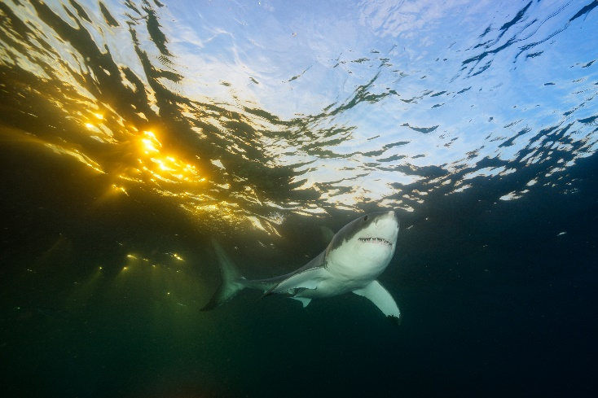To get an elusive up-close view of a great white shark in Cape Cod, photographer Brian Skerry and his team relied on a seal decoy, months of patience, and a lightning-quick finger on the camera shutter.

One possible answer is mating, which might explain why no one has ever observed it. The area is roughly the size of California and thousands of feet deep, which makes it hard to monitor sharks there. But satellite tags tell us that the females swim predictable straight patterns while the males swim up and down in the water column, possibly searching for mates. Thus a rough sketch of the lives of California white sharks is forming. After spending the summer and fall gorging on seals, they head out to the deep ocean to breed, relying on energy stores to live. The males then swim back to the coast while the females wander to unknown places, where they remain for another year or so, perhaps to birth their young. Newborn sharks then show up at feeding grounds—say, the waters off Southern California—devouring fish until they are big enough to join their elders in the north or south hunting seals.

It’s not a perfect picture. Females and males aren’t in the café together for long, and we don’t know where the babies are born. But it explains a lot. For example, as a population rebounds, its young become plentiful, which is likely why Southern Californians have encountered a lot of sharks lately. Yet it’s tougher to figure out elsewhere. Australian sharks forage along the southern coast but don’t seem to have a pattern or café. And in the Atlantic we know even less. “We’ve got wanderers, and we’ve got coastal sharks. And what dictates which, I have no idea,” Skomal says.

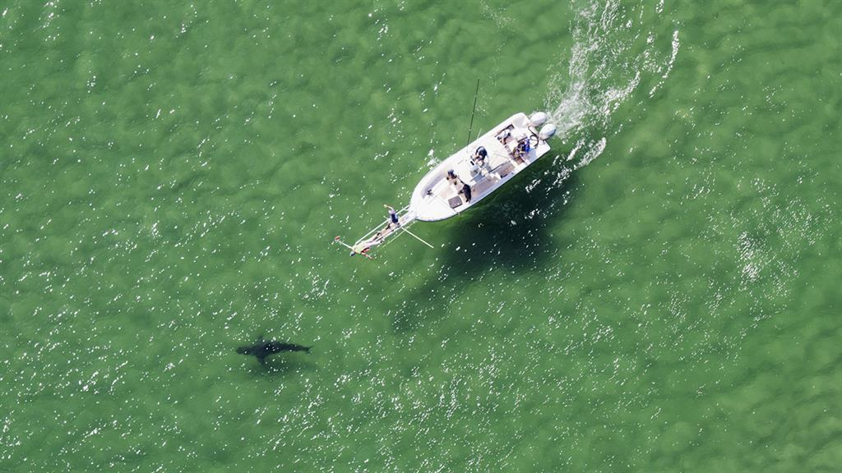

A great white trolls the surface off the southern coast of Australia. In 2015, 33 people were attacked by sharks of all species in the oceans off Australia, according to data from the Taronga Conservation Society Australia.

Even though he doesn’t understand their migrations yet, Skomal is sure that white sharks have a long history here. At his office in New Bedford, just west of Cape Cod, he opens a document that compiled studies of seal bones from Native American archaeological sites along the eastern seaboard. The discarded bones suggest that seal populations crashed from overhunting perhaps a century before the Declaration of Independence. In other words, we’ve had very few Atlantic gray seals throughout the United States’ 240-year history. Today, thanks to the Marine Mammal Protection Act, seal colonies now populate New England. And when the seals returned, the sharks came home as well.

**One bright August morning** I board a two-seater plane with Wayne Davis, a veteran spotter pilot for tuna and swordfish who now helps scientists track down white sharks. Unlike the hubs, the water here is so shallow that sharp eyes can spot them from the air. In just 30 minutes of flying we see seven, all patrolling beaches where gray seals are foraging in open waters. On the way back Davis and I fly past several beaches a mile or so to the north packed with vacationers.

So far locals have embraced their new neighbors. There are stuffed animals, T-shirts, posters, and a community art exhibit called “Sharks in the Park.” Even the new high school’s mascot is a great white. Most of the time the sharks are shown from the side—cheerful, buffoonish. Experts warn, though, that at some point someone here will meet the other version—the one with teeth.

Attacks on people are incredibly rare. In waters off California, the chances of a surfer being bitten by a great white shark are one in 17 million; for swimmers, it’s even rarer—one attack in every 738 million beach visits, according to a recent [Stanford University study](https://news.stanford.edu/2015/07/08/shark-attack-risk-070815/). On Cape Cod, fatalities may not be a question of if, but when. The last lethal shark attack off New England was in 1936, but there have been several close calls recently. A swimmer there was bitten on both legs in 2012, and two paddlers in Plymouth were knocked from their kayaks in 2014, although they escaped unscathed.

If a more serious attack happens, Massachusetts will join the other hubs in weighing the benefits versus the dangers of sharks in their waters.

It may be that great white sharks are rebounding across the world: following the bigger seal and sea lion populations, re-establishing themselves in their old hunting grounds, reclaiming the coasts they nearly lost.

Then again, it may be that great whites today are hanging over the abyss of extinction, clutching the edge by the skin of their jagged teeth. Will we look past our fear and reach out a hand to this creature? Can we take pity on the pitiless eyes of a monster?

[Nat Geo WILD](http://channel.nationalgeographic.com/wild/)'s annual *[SharkFest](http://channel.nationalgeographic.com/wild/sharkfest/" \t "_blank)*launches at 8 p.m. on Sunday, June 26, with *Sharkatraz,* followed by*Return of the Hammerheads.*

COMMENT